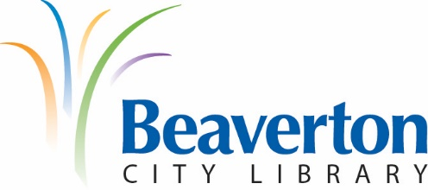

LIBRARY ADVISORY BOARD
MEETING MINUTES
December 9th, 2020

Present: John Henshell, Chair; Kathleen Allen, Vice-Chair; Sarah Larson; Sara Rajkumar; Mei Wong; Andrew Love; Glenn Ferdman, Library Director; Helena Lieu, Teen Library Council; and Kristin Fidler, Administrative Assistant

Absent: Brad Schrock; Lacey Beaty, City Councilor

Guests: none

Chair John Henshell called the meeting to order at 6:06 p.m.

Approval of Minutes from November 4th, 2020 Meeting:
- Sarah Larson called for the approval of the November 4th, 2020 minutes as written. Sara Rajkumar SECONDED the motion to approve the minutes. Motion CARRIED.

Partner Reports

Beaverton Library Foundation: Glenn Ferdman reported that the Foundation’s Fall appeal letter is going out this week and the bookmobile plans are progressing with the Foundation to fund van modifications to a city fleet vehicle.

New Friends of the Beaverton City Library: Kathleen Allen reported that the Friends have two new officers with two more to start after the first of the year. On-line sales continue to be robust and on track with previous years. Donations of used books are still happening. The New Friends have done a phenomenal job raising funds for the library despite COVID restrictions.

Teen Library Council: Helena Lieu reported that the TLC has released a new podcast, the longest one they’ve done so far. The Teen Library Council have been creating “How to” videos for teens and are working on ways to increase teen participation in library programs. The Teen Library Council is also investigating a partnership with the Girl Scouts on a writing project focused on teen perspectives on life during the COVID pandemic. The TLC is also working to support January’s One Book program.

New Business:

Elections of New Officers:
John Henshell was voted to serve as Chair for 2021, and Kathleen Allen was voted to serve as Vice-Chair for 2021. The Board will have two alternate members starting in January 2021.

- Director’s Report & Strategic Plan: Glenn Ferdman reported on the progress of the Book Corner integration and Bookmobile project, and the possibility of moving the branch to a new Sexton Mountain development as the key tenant. The branch’s current lease expires in 2026. Glenn Ferdman also reported on personnel changes and expanded BCL to Go hours. The library hopes to open the Main building to the public in a limited fashion on January 11th, 2021 and is working hard to achieve that goal. The library has added a Spanish language option to the message patrons hear when calling the library. The library will have staff who speak Spanish available to answer questions all hours of service. Glenn Ferdman then presented to the Board his Strategic Planning Process. This process will include many opportunities for input from library staff and community members. Glenn hopes to have the outline of a new plan in place to help guide the budget process that begins in January 2021. The creation of the plan will be driven by the library’s mission, vision and values. It will be easy to remember and implement. This plan will be a three year plan and will be flexible and adaptable to meet the needs of the community.

Set Date for Next Library Advisory Board Meeting:
- The next Board meeting is scheduled for Wednesday, January 13th, 2021, at 6:00 p.m. over the Zoom.gov virtual platform.

Adjournment:
- There being no further business, the meeting was adjourned at 7:32 pm.

Respectfully submitted by:
Glenn Ferdman, Library Director

APPROVED BY:

