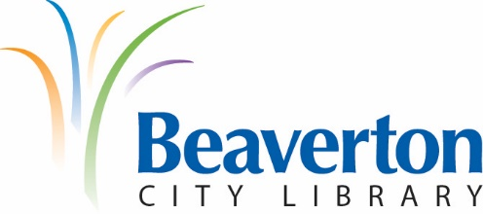

LIBRARY ADVISORY BOARD
MEETING MINUTES
August 12th, 2020

Present: John Henshell, Chair; Sara Rajkumar; Mei Wong; Andrew Love; and Glenn Ferdman, Library Director

Absent: Kathleen Allen, Vice-Chair; Brad Schrock; Lacey Beaty, City Councilor; and Kristin Fidler, Administrative Assistant

Guests: none

Chair John Henshell called the meeting to order at 6:30 p.m.

Because Advisory Board members didn’t receive copies of July’s meeting minutes prior to this meeting, they postponed approving the July minutes until the September meeting.

Partner Reports

Beaverton Library Foundation: Glenn Ferdman reported that library staff are researching Bookmobile and WIFI hotspot options and will help the Foundation with fundraising going forward. The Foundation continues to recruit new members with the library’s Volunteer Coordinator looking at the existing volunteer roster for possible Foundation candidates.

New Friends of the Beaverton City Library: Glenn Ferdman reported that the New Friends continue to sell books online and are exploring storage options with the city should their current location be sold.

New Business:

- Boards & Commissions recruiting process: Chair John Henshell shared an outline of the city’s COVID-19 revised recruitment process for new Boards & Commissions members. The Library Advisory Board is currently full but has two openings for alternates. John Henshell with update the board with more information next month.
- Director’s Report: Glenn Ferdman’s report included information about a variety of library projects including: continued virtual programming through the summer and fall; efforts to improve the WIFI outside near the Main building; the library is now helping to support 12 little free libraries in underserved neighborhoods; Ask the Library now operating 7 days a week; BCL to Go service now operating 6 days a week (with over 5000 appointments served since its inception); the computer lab is now open and is popular with patrons; updates on Adult & Youth Services Summer Reading programs; an onsite walk-through with county Public Health officials to assess limited patron entry possibilities; building out study rooms at Main; and an HVAC audit at Main.
- WCCLS Fine Free Proposal: Glenn Ferdman shared that in an effort to reduce barriers and advance equitable access to library services, the Washington County Cooperative Policy Group has been exploring going fine-free with a hopeful start date of January 2021.

Set Date for Next Library Advisory Board Meeting:
- The next Board meeting is scheduled for Wednesday, September 9th at 6:00 p.m. over the Zoom.gov virtual platform.

Adjournment:
- There being no further business, the meeting was adjourned at 7:34 pm.

Respectfully submitted by:
Glenn Ferdman, Library Director

APPROVED BY:

